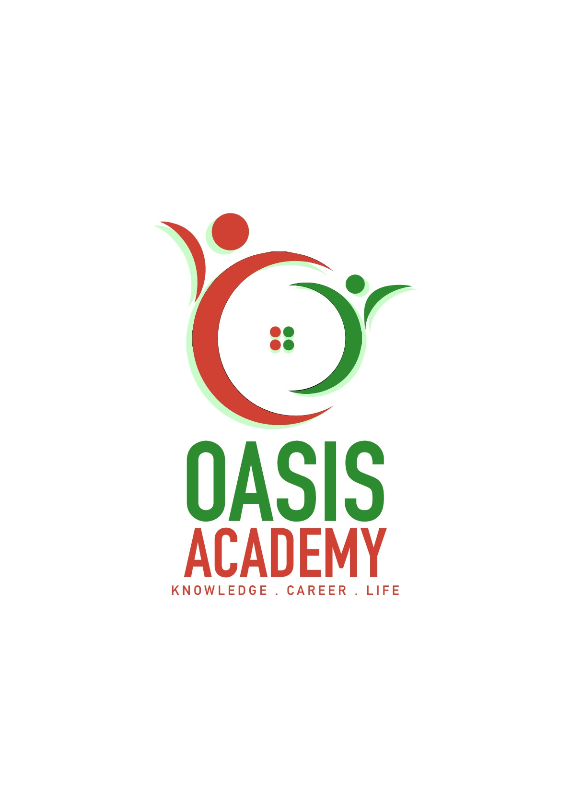

Name: Saravanan Subramaniam

Login ID: saravanan@oasis-portal.com

Course title: Tourism and Hospitality

Subject Code: BHM 04

Submitted date: 11th September 2017

**Table of Contents**

|  |  |  |
| --- | --- | --- |
| **No** | **Details** | **Page** |
| 1 | Executive Summary | 2 |
| 2 | Introduction | 3 |
| 3 | Assignment Question |  |
|  | Part 1 | 4 - 6 |
|  | Part 2 | 7 - 9 |
|  | Part 3 | 10 - 11 |
|  | Part 4 | 12 - 13 |
| 4 | Conclusion | 14 |
| 5 | References | 15 - 16 |
|  |  |  |

**Executive Summary**

The purpose of this assignment is what I understand about tourism and hospitality. I will define tourism and hospitality. Then will be brief about the type of tourism categories. In addition will be explaining the lodging accommodation and the type of hotel accommodation. Finally I will covered about the significant of the entertainment in tourism and hospitality industry.

**Introduction**

What is tourism? Tourism is a dynamic and competitive industry that requires the ability to adapt constantly to customer’s changing needs and desire, as the customer satisfaction, safety and enjoyment. Particularly the focus of tourism business. Marketing of the enjoyable and other features of a travel destination and provision of facilities and services for the pleasure of travelers (tourists). Tourism comprises the activities of person travelling to and staying in place outside from usual environment for not more than one consecutive year for leisure business and other purposes. In addition tourism that takes full account of its current and future economic, social and environmental impacts, addressing the needs of visitor.

Hospitality is about providing food, drink and accommodation. It’s also involves entertainment, fitness and leisure workers. The hospitality industry is much broader than most other industries. But this industry applies to nearly any company that focused on customer satisfaction. This industry relies entirely on customer being happy. The hospitality industry is there servicing business conducing another significant branch in the economics of the country. Associates many type of industry such tourist, the transportation and food servicing.

**Assignment Questions**

**Question 1**

Define the Tourism and Hospitality.

Explain your understanding about Hospitality Industry.

**Answer**

Tourism is a multi-disciplinary field of study with the purpose of preparing people with expertise, commitment and skill for management, marketing and operation. The expanding industry that provide food, accommodation and tourism services to people away from home. Tourism is the business of providing services for people on holiday for example hotels, restaurants and trips. A social, cultural and economic phenomenon which entail the movement of people to countries or place outside from usual environment for personal or business purposes.

What is meaning of hospitality? There have been different definition of hospitality. The act of kindness in welcoming and looking after the basic needs of a guests, mainly in relation food, drink and accommodation. Refers to the relationship process between a guest and a host. The scope of this industry and its characteristics of involving both tangible and intangible features in the service delivery. One of the most defining aspects of this hospitality industry is that it focus on customer satisfaction. The hospitality industry is a board category of field within services industry that includes lodging, event planning, theme parks, transportation, cruise line and additional field within tourism industry.

Largest and fastest growing industry in the world. One of the most exciting aspect of this industry is that it is made up of so many profession. The hospitality and tourism industry is diverse and includes many location including RV parks, food establishment, recreational facilities, camp grounds, boarding houses and youth hostels. The industry of providing customer services to traveler or stranger. More responsible for overseeing the operations and success of an establishment such as hotel and restaurant. Hospitality is to ensure that guests and customer have pleasurable experience, can also be responsible for operation such as hiring and training new staff.

A contemporaneous human exchange which is voluntarily entered into and designed to enhance the mutual well-being of the parties concerned through the provision of accommodation and food and beverages. Moreover customer do not buy service delivery but buy experience and do not buy service quality but buy memories. Hospitality requires the guest to feel that the host is being hospitable through feelings of generosity a desire to please and a genuine regard for the guests as an individual. It is concerned with more than food, drink and shelter. Traditionally the most important responsibility of all was the guest’s safety.

**Front of the house**

Staff or employees who has a direct contact with a guest or customer. He or she will greet, welcome, assist, provide and deliver a good services and products to the guest as well. Also become a person who will give a great good first impression to the guest too. The several front of the house staff members such as:

* Waiter / waitress
* Bartenders
* Greeter
* Manager
* Receptionist

**Back of the house**

Performing duties behind the scenes the profound and most challenging, reality of working in this industry. He or she may or may not has a limited time to meet the guests too. The several back of the house staff member such as:

* Chef
* Housekeeper
* Stewards
* Food purchaser
* Night audit
* Dishwasher
* Public area (maid)

**Question 2**

Brief on different type of tourism categories. Define tourism.

**Answer**

The tourism sector is one of the largest money – generating sector in the world. It is an ever developing industry, where new niches seems to crop up every now and then. As a concept has come a long way today and the activity has been classified into various categories. The different categories of tourism are as under:-

1. Recreation tourism

This is when people go to a place that is a different from regular day-to-day life to relax and have fun. Beaches, theme park and camp grounds are the often the most common place.

1. Cultural tourism

To get know its history and cultural then this the type of tourism called as cultural tourism. May visit different landmark of a particular country. Also attend festival and ceremonies in order to gain a better understanding of people, belief and practices.

1. Nature tourism

For tourists who want to see wildlife or bask in the joy of just being in the midst of nature. Eco tourism and nature trek are all part of this kind of tourism. Bird watching for example is one the activity that nature tourists are fond of doing. It is environmentally responsible has low impact and advantageous to the local community.

1. Pleasure tourism

Many people today are stressed out in the corporate rat race and in the need of rejuvenation. Go on trips that refresh souls and spirits. Usually include yoga workshops, detox vacation among others.

1. Sport tourism

Travelers here target place which known for a particular sporting facility. Skiing for example is a type of tourism. Also included in this category are those who go to a destination to experience sport such as FIF World Cup, Olympic and other.

1. Religious tourism

Is another type of tourism where people go to a religious location or locations to follow the footsteps of their founder or to attend a religious ceremony?

1. Medical and health tourism

Where the main focus of the travel is improving one’s health, physical appearance and fitness. Moreover certain countries promote the expertise of doctors and surgeons in the field of cosmetic surgery.

1. Adventure tourism

That is catered for those who want to do more than just visit regular tourist’s sites. These kind trips involve challenging activities like rock climbing, mountain climbing, and wild water rafting.

Tourism is the activity or practice touring especially for pleasure. The business or industry of providing information, accommodation, transportation and other services to tourists. Is the act of travel for mainly relaxation and business purposes? Furthermore tourism is not only a leisure and fun activity. Rather it is also the industry which draws accommodation and entertains tourists and help generates income for the country. Tourism opportune us to explore new culture, meet new people and do fun and adventure at different places. It’s also helps in the economic progress of a country and generates employment too. Tourism is also a wonderful method for cultural exchange.

**Question 3**

Describe the lodging accommodation and type of hotel accommodation.

**Answer**

What is lodging accommodation? Companies that develop, own, manage and operate lodging facilities including motels and full services hotels, usually out in nature, often made from logs, woods or other natural material. Designated to optimize the feeling being close in touch of nature. The building style should feature nature materials and coloring such as wood, stone and thatch. An outdoor experienced should be offered at the lodge such as guided walks, game drives etc. lodging may be self- catering in which case no food provided but cooking facilities is available. In addition lodging for sleep, rest, safety, shelter from cold temperature, storage of luggage and common household function.

The definition of an accommodation is something that fulfills a particular needs. Accommodation facilities play a very important role in popularizing any tourist’s destination. The form of low budget lodges or hotels to world class luxury hotel also available at all the major tourist destination to provide the tourists a home away from home. That provide a place for the tourist to stay. Moreover accommodation one of the components of travel make the experience more cheerful and memorable.

1. Hotel

A hotel generally the largest of all accommodation types. There is typically a common reception area and room generally open directly onto a hallway. The on-site restaurant and other facilities are more accessible to the public then the other accommodation type. A wide range of guest services is available such a room services.

1. Resort

A spread out collection of single or double story accommodation units. Similar to a hotel in that is offers a wide range facilities. Units may be rented and available on time share. Usually used for vacation or getaways. Along with hotel room will be common areas amenities, swimming pool, dining, game room and other facilities.

1. Boutique hotel

A boutique hotel is a 5 star establishment all the features and facilities of a normal hotel in a unique and exclusive style. These properties are generally small, feature top class service and marketed to the affluent.

1. Motel

Room usually open out to parking lot. As the name implies it cater mostly to motorist. The motel are owned privately and these are old fashioned.

1. Bed and Breakfast

Is a private home which guests are be accommodation at night in private bedrooms? The owner or manager lives in the house or on the property. The public area of the house such kitchen and lounge have either limited access for guests. Breakfast include in the price and other meals may be available by arrangement.

**Question 4**

Explain the significant of entertainment of this industry.

**Answer**

Entertainment is a form of activities take a way people stress basically come from school or work and give properly amusement to relax. In tourism industry entertainment is an important sector. Tourists would love to visit some specific place such movie theaters, Water Park, carnival and so on. Tourism is the second largest group of employment and its happens to be most diverse. Some jobs in recreation and entertainment field include movie theater manager, casino dealer, google employee, museum, ski instructor and so on. There is a large of variety of things can do in the entertainment.

This is an again key category of the hospitality industry as it involve the most important thing of hospitality. The buyer and recipient of all hospitality services. So this sector of hospitality thrives for all and to entertain. Entertainment is a significant part of travel these days. If travelling experience lacks of fun and entertainment then might not be able enjoy. Moreover for the successful running of a hospitality business it is important as many entertainment activities as possible. Recreation is any activity that people do for rest, relaxation and enjoyment.

Some of the activities which can elevate experience when it comes to entertainment.

1. Marinas

Are one of the most popular places to go when it’s come to partying, can get along with peers on a private yacht where can dance, play games and enjoy the best of life.

1. Sports and gaming

Is a basic things which people are looking for on their travel? As a result casino, swimming pool and other similar activities are becoming an indispensable part of the hospitality industry.

1. Cruise

Apart from marinas, cruise services are also becoming an essential components of the hospitality industry. Now people like to spend their days on luxury ships which sail across the blue oceans under clear sky.

1. Nightclubs

Who doesn’t love to dance on their favorite song when on a break? We all do. This why hotels have nightclubs services in them.

1. Bars

Sitting around a table and having a couple of drinks with friends is always a refreshing experience. This why bars make an important part of entertainment sector of the hospitality industry.

**Conclusion**

In this part, finally I learned and covered about tourism and hospitality industry. Tourism is a dynamic and competitive industry that requires the ability to adapt constantly to customer’s changing needs and desire, as the customer satisfaction, safety and enjoyment. Hospitality is about providing food, drink and accommodation. It’s also involves entertainment, fitness and leisure workers. The hospitality industry is much broader than most other industries. Largest and fastest growing industry in the world. One of the most exciting aspect of this industry is that it is made up of so many profession. The hospitality and tourism industry is diverse and includes many location including RV parks, food establishment, recreational facilities, camp grounds, boarding houses and youth hostels. As a concept has come a long way today and the activity has been classified into various categories. The different categories of tourism such as cultural tourism, religious tourism, adventure tourism and so on. What is lodging accommodation? Companies that develop, own, manage and operate lodging facilities including motels and full services hotels, usually out in nature, often made from logs, woods or other natural material. Accommodation facilities play a very important role in popularizing any tourist’s destination. The form of low budget lodges or hotels to world class luxury hotel also available at all the major tourist destination to provide the tourists a home away from home. Entertainment is a form of activities take a way people stress basically come from school or work and give properly amusement to relax. In tourism industry entertainment is an important sector. Tourists would love to visit some specific place such movie theaters, Water Park, carnival and so on.

**References**

1. Wikipedia

<https://en.m.wikipedia.org/wiki/Tourism>

1. Mike joseph ( Jul 7, 2015) Tourism ( importance)

<https://www.slideshare.net/mobile/MikeOdias/tourism-importance-of-tourism>

1. Angela Francisco ( Apr 19, 2015) Meaning of tourism

<https://www.slideshare.net/mobile/JhelleEnFrances/meaning-and-importance-of-tourism>

1. Herasquivel ( oct 7, 2014) Introduction to Hospitality industry

<https://www.slideshare.net/mobile/heraesquivel/introduction-to-hospitality-industry-39956160>

1. Sunil kumar (Dec 9, 2013) introduction to hospitality

<https://www.slideshare.net/mobile/SunilKumar148/all-fb-1-yr-basics>

1. The tourism society

<http://www.tourismsociety.org/page/88/tourism-definitions.htm>

1. Ennaira Saint ( July 4, 2014) Sector of tourism

<https://www.slideshare.net/mobile/enairrasaint/sectors-in-tourism>

1. Althin Bak0 ( July 21, 2013) Types of tourism

<https://www.slideshare.net/mobile/ALTINBAKU/the-different-types-of-tourism>

1. Tourism Council

<http://www.tourismcouncilwa.com.au/2016-categories>

1. Charlie Zabala ( Jan 26, 2015) Lodging accommodation

<https://www.slideshare.net/mobile/charliezabala7/lodging-accommodation>

1. Nicoleh Walter (Dec 2 , 2014) Lodging Industry

<https://www.slideshare.net/mobile/nicolehaywalters/chapter-1-the-lodging-industry>

1. Blurtit

<http://science.blurtit.com/1077445/what-is-the-importance-of-tourism-industry>

1. Wikipedia

<https://en.m.wikipedia.org/wiki/Hospitality>

1. Wikipedia

<https://en.m.wikipedia.org/wiki/Hospitality_industry>

1. Encyclopedia

<http://www.encyclopedia.com/history/dictionaries-thesauruses-pictures-and-press-releases/hotels-and-hotel-industry>

1. Michelle Reynolds categories in hospitality industry

<http://smallbusiness.chron.com/three-categories-hospitality-industry-58524.html>

1. Roma Gandhi ( July 22,2016) introduction to hotel industry

<https://www.slideshare.net/mobile/RomaGandhi3/introduction-to-hotel-industry-64288793>

1. Anamena (Jan 28, 2015) types of accommodation

<https://www.slideshare.net/mobile/anamena78/types-of-accommodation-43990556>

1. Roopeshv ( feb 24, 2015) entertainment

<https://www.slideshare.net/mobile/roopeshv149/attraction-shopping-entertainment-components-of-tourism>

THE END